

Faculty of Engineering (Degree)
Semester – 1
Subject Name – Programming for Problem Solving
Subject Code – BE200104
Faculty Name – Ashwini Walake
Unit -1: Introduction to Computer and Programming

Introduction to Computer:
A computer is a programmable electronic device that accepts raw data as input, processes it according to a set of instructions, and generates valuable information as output. It is the foundation of modern technology, driving how we work, communicate, and solve problems.
How Computers Work
A complete computer system relies on two main pillars to function:
- Hardware: The physical and mechanical components you can touch, such as the motherboard, CPU, monitor, and memory.
- Software: The digital instructions and programs that tell the hardware exactly what to do, which includes operating systems (like Windows, macOS, or Linux) and specific applications.
Core Computer Applications
Computers power nearly every industry through specialized software applications. Key applications include:
- Business & Finance: Powering inventory tracking, digital transactions, payroll systems, and data analytics platforms.
- Education: Enabling online learning platforms, digital libraries, and virtual classrooms.
- Healthcare: Storing and retrieving patient electronic health records (EHR), running diagnostic tools, and aiding in medical research.
- Communication & Entertainment: Facilitating email, social media, video conferencing, media streaming, and video games

Block diagram of computer and functions of different units:
A computer's block diagram outlines how information flows through the system. It consists of five core components: an Input Unit, Memory Unit, Central Processing Unit (CPU) (which contains the Control Unit and ALU), and an Output Unit. All components communicate via system buses.
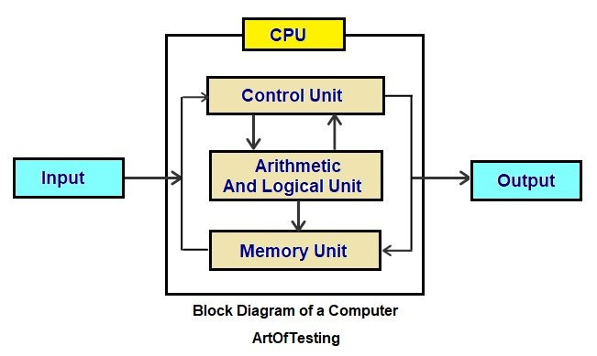
Core Computer Components & Their Functions
1. Input Unit
- Function: Converts raw data and instructions from the user into machine-readable formats.
- Examples: Keyboards, mice, scanners, and microphones.
2. Central Processing Unit (CPU)
Often called the "brain" of the computer, the CPU executes commands and processes data. It is divided into two primary sub-components:
- Arithmetic Logic Unit (ALU): Performs all mathematical calculations (addition, subtraction, etc.) and logical comparisons (e.g., determining if A > B)
- Control Unit (CU): Acts as the central nervous system, directing and coordinating the operations of all other parts. It fetches, decodes, and executes instructions from memory.
3. Memory Unit
Stores data and instructions before, during, and after processing. It is categorized into two main types:
- Primary Memory (RAM): Volatile, temporary storage used by the CPU for active programs and data.
- Secondary Memory: Non-volatile, permanent storage for long-term data preservation. Examples include SSDs, HDDs, and USB drives.
4. Output Unit
- Function: Translates the processed information (which is in machine-readable code) into a human-readable format.
- Examples: Monitors, printers, and speakers.
5. System Buses
- Function: The physical wires or pathways that transmit data, addresses, and control signals between the CPU, memory, and I/O devices
Computer Systems:
A computer is a system made of two major components: hardware and software. The computer hardware is the physical equipment. The software is the collection of programs (instructions) that allow the hardware to do its job.
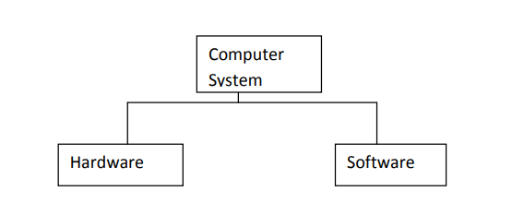
Computer Hardware
The hardware component of the computer system consists of five parts: input devices, central processing unit (CPU), primary storage, output devices, and auxiliary storage devices.
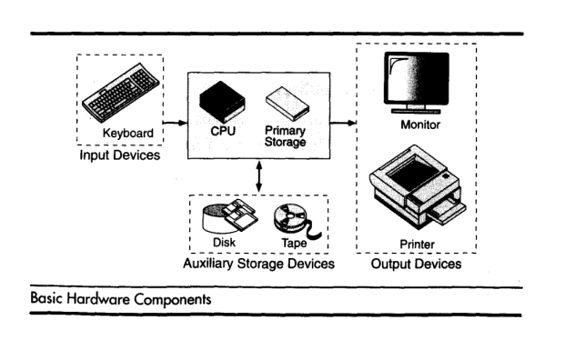
The input device is usually a keyboard where programs and data are entered into the computers. Examples of other input devices include a mouse, a pen or stylus, a touch screen, or an audio input unit.
The central processing unit (CPU) is responsible for executing instructions such as arithmetic calculations, comparisons among data, and movement of data inside the system.
Today’s computers may have one ,two, or more CPUs .Primary storage ,also known as main memory, is a place where the programs and data are stored temporarily during processing. The data in primary storage are erased when we turn off a personal computer or when we log off from a time-sharing system.
The output device is usually a monitor or a printer to show output. If the output is shown on the monitor, we say we have a soft copy. If it is printed on the printer, we say we have a hard copy.
Auxiliary storage, also known as secondary storage, is used for both input and output. It is the place where the programs and data are stored permanently. When we turn off the computer, or programs and data remain in the secondary storage, ready for the next time we need them.

Computer Software
Computer software is divided in to two broad categories: system software and application software .System software manages the computer resources .It provides the interface between the hardware and the users.
Application software, on the other hand is directly responsible for helping users solve their problems.
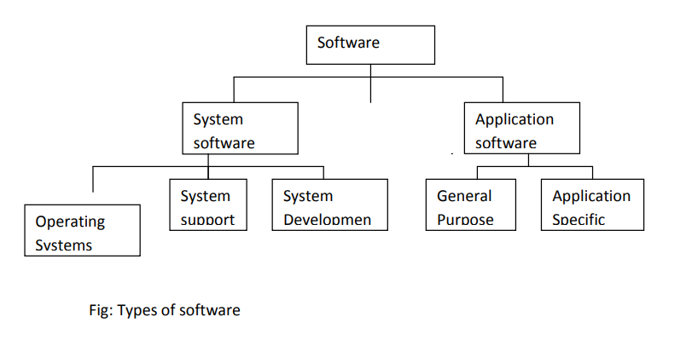
Types of Software
1)System Software:
System software consists of programs that manage the hardware resources of a computer and perform required information processing tasks. These programs are divided into three classes: the operating system, system support, and system development.
The operating system provides services such as a user interface, file and database access, and interfaces to communication systems such as Internet protocols. The primary purpose of this software is to keep the system operating in an efficient manner while allowing the users access to the system.
System support software provides system utilities and other operating services. Examples of system utilities are sort programs and disk format programs. Operating services consists of programs that provide performance statistics for the operational staff and security monitors to protect the system and data.
The last system software category ,system development software, includes the language translators that convert programs into machine language for execution ,debugging tools to ensure that the programs are error free and computer –assisted software engineering(CASE) systems.
Example: windows, macos, linux
2) Application software
Application software is broken in to two classes: general-purpose software and application – specific software. General purpose software is purchased from a software developer and can be used for more than one application. Examples of general purpose software include word processors, database management systems ,and computer aided design systems. They are labelled general purpose because they can solve a variety of user computing problems.
Application–specific software can be used only for its intended purpose.
A general ledger system used by accountants and a material requirements planning system used by a manufacturing organization are examples of application-specific software. They can be used only for the task for which they were designed they cannot be used for other generalized tasks.
Example: Microsoft word, excel, zoom, canva
What is a Compiler?
The Compiler is a translator that takes input i.e., High-Level Language, and produces an output of low-level language i.e. machine or assembly language. The work of a Compiler is to transform the codes written in the programming language into machine code (format of 0s and 1s) so that computers can understand.
- A compiler is more intelligent than an assembler it checks all kinds of limits, ranges, errors, etc.
- But its program run time is longer and occupies a larger part of memory. It has a slow speed because a compiler goes through the entire program and then translates the entire program into machine codes.

Role of a Compiler
For Converting the code written in a high-level language into machine-level language so that computers can easily understand, we use a compiler. Converts basically convert high-level language to intermediate assembly language by a compiler and then assembled into machine code by an assembler.
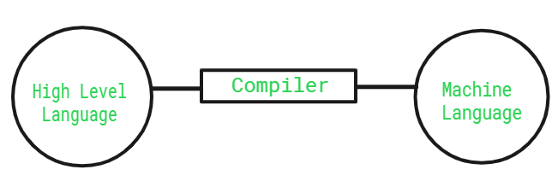Compiler
Advantages of Compiler
- Compiled code runs faster in comparison to Interpreted code.
- Compilers help improve the security of Applications.
- Compilers give Debugging tools, which help in fixing errors easily.
Disadvantages of Compiler
- The compiler can catch only syntax errors and some semantic errors .
- Compilation can take more time in the case of bulky code.
What is an Interpreter?
An Interpreter is a program that translates a programming language into a comprehensible language. The interpreter converts high-level language to an intermediate language. It contains pre-compiled code, source code, etc.
- It translates only one statement of the program at a time.
- Interpreters, more often than not are smaller than compilers.
Role of an Interpreter
The simple role of an interpreter is to translate the material into a target language. An Interpreter works line by line on a code. It also converts high-level language to machine language.
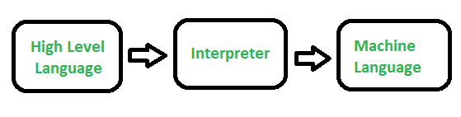Interpreter
Advantages of Interpreter
- Programs written in an Interpreted language are easier to debug.
- Interpreters allow the management of memory automatically, which reduces memory error risks.
- Interpreted Language is more flexible than a Compiled language.
Disadvantages of Interpreter
- The interpreter can run only the corresponding Interpreted program.
- Interpreted code runs slower in comparison to Compiled code.
Difference Between Compiler and Interpreter
Both compilers and interpreters serve the same purpose but work in different ways.

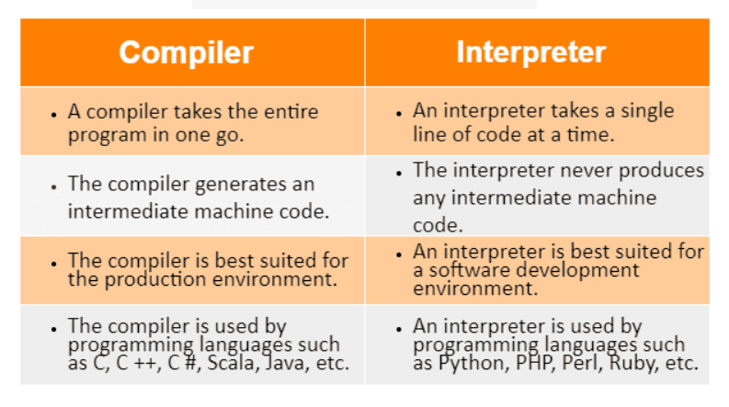
Conclusion
In summary, compilers and interpreters both serve the purpose of converting high-level code into something a computer can understand, but they do so in different ways. A compiler translates the whole program at once, which can make it run faster but takes more time to compile. An interpreter translates and runs the code line by line, making it easier to catch errors and debug, though it may run slower.
What is an Assembler?
An assembler is a system software program that translates low-level assembly language code into binary machine code (object code) that the computer's CPU can directly execute.
Key Functions of the Assembler
- Translates Mnemonics: Converts text-based human-readable operational symbols into strict binary operational codes (opcodes).
- Resolves Memory Labels: Map alphanumeric symbolic labels used for variables or function jumps into concrete offset addresses or memory locations.
- Handles Directives: Processes metadata statements intended purely for the assembler tool itself, such as defining data storage allocations or alignments.

Concept of Machine-Level Language
Machine level language, also known as machine code, is the lowest-level programming language directly understood by a computer's central processing unit (CPU). It consists of binary instructions (sequences of 0s and 1s) that the CPU can execute without any translation.
While C is a high-level language, it allows for low-level programming concepts, providing a bridge between human-readable code and machine-level operations:
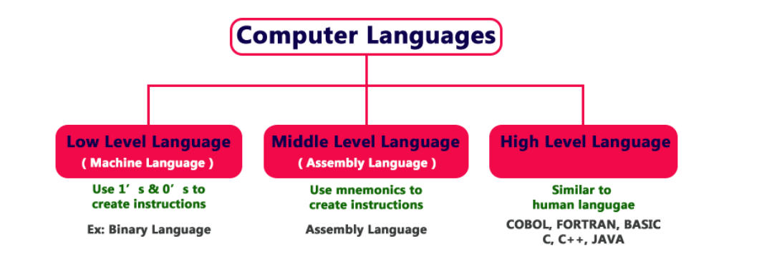

Programming Language is categorized into assembly language and high-level language. Assembly-level language is a low-level language that is understandable by machines whereas High-level language is human-understandable language.
What is Assembly Language?
It is a low-level language that allows users to write a program using alphanumeric mnemonic codes, instead of numeric code for a set of instructions examples of large assembly language programs from this time are IBM PC DOS.
Examples: x86, ARM Assembly, MIPS Assembly
Advantages
- Execution of code is efficient
- Low-level operations can be performed
- High control over Hardware
Disadvantages
- More Complex
- More time consuming
- Lack of Portability
What is High-Level Language?
It is a machine-independent language. It enables a user to write a program in a language that resembles English words and familiar mathematical symbols, COBOL was the first high-level language.
Examples of high-level language are python,c#, etc.
Examples
- Python
- Java
- C++
Advantages
- Increase Readability
- Portability
- Faster Development
Disadvantages
- Slower Execution
- Memory Usage
- Less Control Over Hardware

Difference Between Assembly Language and High Level Language
ASSEMBLY LEVEL LANGUAGE | HIGH-LEVEL LANGUAGE
It needs an assembler for conversion | It needs a compiler/interpreter for conversion
In this, we convert an Assembly level language to machine level language | In this, we convert a high-level language to Assembly level language to machine level language
It is machine dependent | It is machine-independent
It supports low-level operation | It does not support low-level language
In this, it is easy to access hardware component | In this, it is difficult to access hardware component
In this more compact code | No compactness

Problem Solving Methodology:
Problem-solving techniques in computer science are structured, algorithmic, or heuristic methods used to break down complex issues into manageable, executable code.
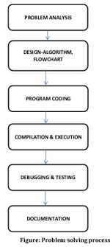
Step 1: Identify and Define Problem
Explain you problem clearly as possible as you can.
Step 2: Generate Possible Solutions
- List out all the solution that you find. Don’t focus on the quality of the solution
- Generate the maximum number of solution as you can without considering the quality of the solution
Step 3: Evaluate Alternatives
After generating the maximum solution, Remove the undesired solutions.
Step 4: Decide a Solution
After filtering all the solution, you have the best solution only. Then choose on of the best solution and make a decision to make it as a perfect solution.
Step 5: Implement a Solution:
After getting the best solution, Implement that solution to solve a problem.
Step 6: Evaluate the result
After implementing a best solution, Evaluate how much you solution solve the problem. If your solution will not solve the problem then you can again start with Step 2.
Algorithm:
A step-by-step set of instructions to solve a problem or complete a task.
Algorithms was developed by an Arab mathematician. It is chalked out step-by-step approach to solve a given problem. It is represented in an English like language and has some mathematical symbols like ->, >, <, = etc. To solve a given problem or to write a program you approach towards solution of the problem in a systematic, disciplined, non-adhoc, step-by-step way is called Algorithmic approach. Algorithm is a penned strategy(to write) to find a solution.
Example: Algorithm/pseudo code to add two numbers
Step 1: Start
Step 2: Read the two numbers in to a,b
Step 3: c=a+b
Step 4: write/print c
Step 5: Stop.

Flow Chart :
A Flow chart is a Graphical representation of an Algorithm or a portion of an Algorithm.
Flow charts are drawn using certain special purpose symbols such as Rectangles, Diamonds, Ovals and small circles. These symbols are connected by arrows called flow lines.
(or)
The diagrammatic representation of way to solve the given problem is called flow chart.
The following are the most common symbols used in Drawing flowcharts:
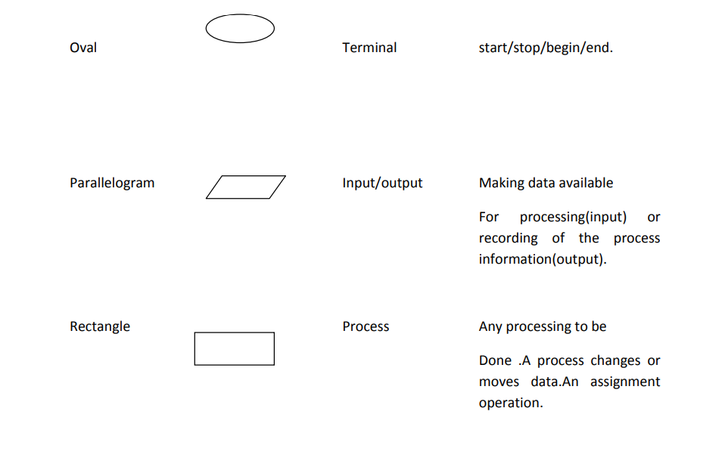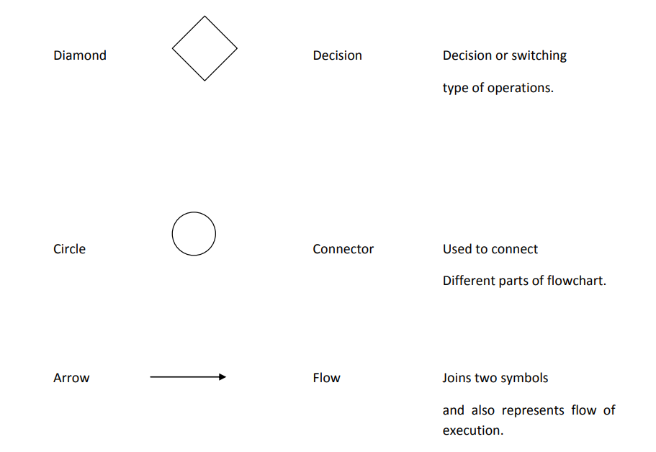

Introduction to ai assisted coding tools and their ethical use in programming:
AI coding tools help you write software faster. However, using them requires you to be careful, honest, and responsible.
Popular AI Coding Tools
- Cursor & Copilot: Tools built into your code editor to write and edit code for you.
- Claude Code: A smart assistant that can read and change your entire project folder.
- Tabnine: An AI tool that focuses on keeping your private code safe and secret.
- ChatGPT: A helpful chat partner to brainstorm ideas and explain tricky concepts.
The Big Risks
- Plagiarism: AI can accidentally copy code owned by someone else, causing legal trouble.
- Leaking Data: If you paste private company code into a public AI, anyone might see it.
- Bad Security: AI makes mistakes and often suggests code that has bugs or security flaws.
- Lazy Habits: If you let AI do all the thinking, your own coding skills will get worse.
- Blame: If the app breaks, you are responsible for the damage, not the AI.
How to Use AI Ethically
- Check everything: Read every line of AI code carefully before you use it.
- Test the code: Run safety scans and tests to ensure the AI did not introduce bugs.
- Protect privacy: Use business accounts that promise not to save or steal your code.
- Block copying: Turn on settings that stop the AI from showing you copyrighted code.
- Learn, don't just copy: Use AI to explain how things work, not just to do the work for you.

